TC-VER-005
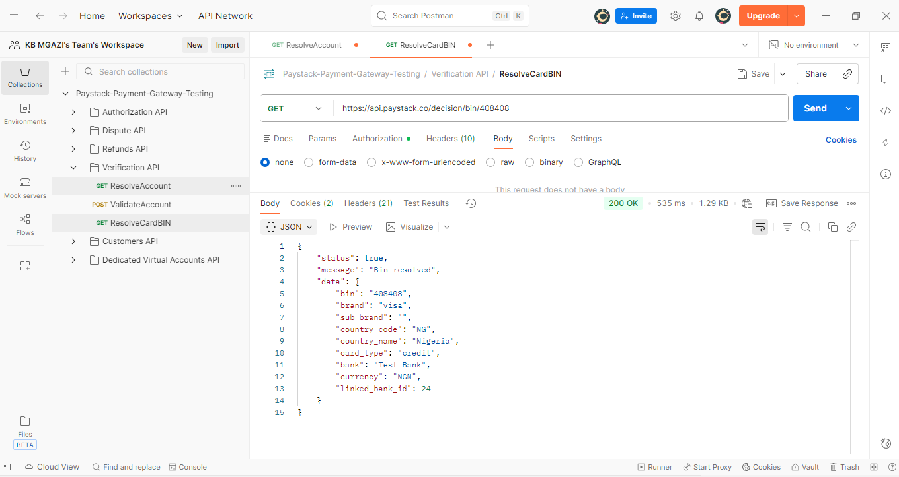
Response:
{
"status": true,
"message": "Bin resolved",
"data": {
"bin": "408408",
"brand": "visa",
"sub_brand": "",
"country_code": "RSA",
"country_name": "South Africa",
"card_type": "credit",
"bank": "Test Bank",
"currency": "ZAR",
"linked_bank_id": 24
}
}

